Module Design Document
For
ES36B_PhaseAbcFdbkMeas

VERSION: 1.0
DATE: 05-17-2016

Prepared By:
Software Engineering Group,
Nexteer Automotive,
Saginaw, MI, USA
Location: The official version of this document is stored in the Nexteer Configuration Management System.

Revision History

Sl. No. | Description | Author | Version | Date
1 | Initial Version | Avinash James | 1.0 | 05-17-2016

Table of Contents
1 Abbrevations And Acronyms 5
2 References 6
3 PhaseFdbkMeas & High-Level Description 7
4 Design details of software module 8
4.1 Graphical representation of PhaseFdbkMeas 8
4.2 Data Flow Diagram 8
4.2.1 Module level DFD 8
4.2.2 Sub-Module level DFD 8
4.3 COMPONENT FLOW DIAGRAM 8
5 Variable Data Dictionary 9
5.1 User defined typedef definition/declaration 9
5.2 Variable definition for enumerated types 9
6 Constant Data Dictionary 10
6.1 Program(fixed) Constants 10
6.1.1 Embedded Constants 10
6.1.1.1 Local 10
6.1.1.2 Global 10
6.1.2 Module specific Lookup Tables Constants 10
7 Software Module Implementation 11
7.1 Sub-Module Functions 11
7.2 Initialization Functions 11
7.2.1 Init: Cd_PhaseFdbkMeas_Init2 11
7.2.1.1 Design Rationale 11
7.2.1.2 Module Outputs 11
7.2.1.3 Module Internal 11
7.3 PERIODIC FUNCTIONS 11
7.3.1 Per: Cd_PhaseFdbkMeas_Per1 11
7.3.1.1 Design Rationale 11
7.3.1.2 Store Module Inputs to Local copies 11
7.3.1.3 Processing of function 11
7.3.1.4 Store Local copy of outputs into Module Outputs 12
7.3.2 SEr: Get_PhaseFdbk_PhaseFdbk 12
7.3.2.1 Design Rationale 12
7.3.2.2 Store Module Inputs to Local copies 12
7.3.2.3 Processing of function 13
7.3.2.4 Store Local copy of outputs into Module Outputs 13
7.4 Interrupt Functions 13
7.4.1 Isr: <ModuleName>_Isr<n> 13
7.4.1.1 Design Rationale 13
7.4.1.2 (Processing of the ISR function)….. 13
7.5 Serial Communication Functions 14
7.5.1 SComm: <MODULENAME> 14
7.5.1.1 Design Rationale 14
7.5.1.2 Store Module Inputs to Local copies 14
7.5.1.3 (Processing of function)……… 14
7.5.1.4 Store Local copy of outputs into Module Outputs 14
7.6 Local Function/Macro Definitions 14
7.7 GLObAL Function/Macro Definitions 14
7.7.1 Init: Cd_PhaseFdbkMeas_Init1 14
7.7.1.1 Design Rationale 14
7.7.1.2 Module Outputs 14
7.7.1.3 Module Internal 14
8 Known Limitations With Design 15
9 UNIT TEST CONSIDERATION 16
10 Appendix 17

Abbrevations And Acronyms
Abbreviation | Description
DFD | Design functional diagram
MDD | Module design document
FDD | Functional design document

References
This section lists the title & version of all the documents that are referred for development of this document
Sr. No. | Title | Version
1 | MDD Guidelines | 1.3
2 | Software Naming Conventions | 1.2
3 | Coding standards | 2.1
4 | FDD: 36B - PhaseAbcFdbkMeas | 1.0.0

PhaseABCFdbkMeas & High-Level Description

This module implements NHET2 initialization per “36B - PhaseAbcFdbkMeas” FDD for Phase Feedback Measurement. This module get phase feedback accumulator information from phase inverter state measurement, then calculate the MeasureOnTime in a periodical runnable.
The N2HET2 will be required to perform the following functions:
- ABC phase inverter state feedback monitoring
  - Digital input for each inverter phase voltage state
  - One output per channel (Low Res)

Design details of software module

Graphical representation of PhaseABCFdbkMeas

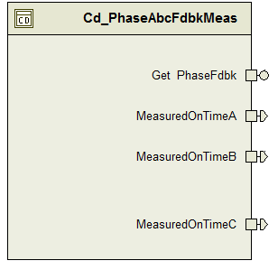

Data Flow Diagram
None

Module level DFD
None

Sub-Module level DFD
None

COMPONENT FLOW DIAGRAM
None

Variable Data Dictionary

User defined typedef definition/declaration
None

Variable definition for enumerated types
None

Constant Data Dictionary

Program(fixed) Constants

Embedded Constants

Local
Constant Name | Resolution | Units | Value
D_PHASEA_CNT_U8 | 1 | Cnt | 0
D_PHASEB_CNT_ U8 | 1 | Cnt | 1
D_PHASEC_CNT_ U8 | 1 | Cnt | 2
D_PXACCUMMAX_CNT_U32 | 1 | Cnt | 536870911UL

Global
None

Module specific Lookup Tables Constants
None

Software Module Implementation

Sub-Module Functions
None

Initialization Functions

Init: Cd_PHASEABCFDBKMEAS_Init2

Design Rationale
This init function will give initial values to PhaseAbcFdbkMeas_PhaseXPrevFdbk_Cnt_M_u32 array.

Module Outputs
None

Module Internal
None

PERIODIC FUNCTIONS

Per: Cd_PHASEABCFDBKMEAS_Per1

Design Rationale
None

Store Module Inputs to Local copies
None

Processing of function
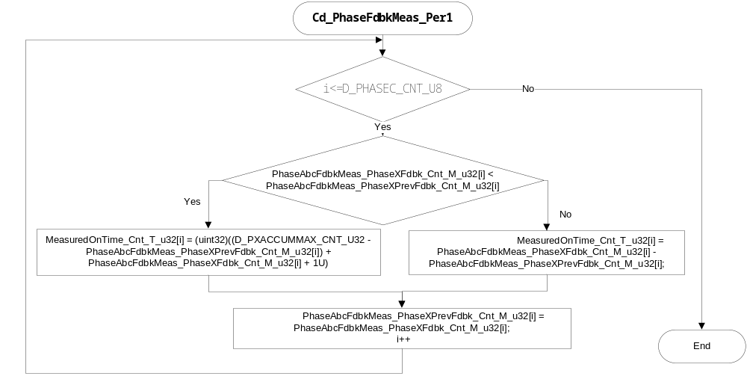

Store Local copy of outputs into Module Outputs
Rte_IWrite_Cd_PhaseAbcFdbkMeas_Per1_MeasuredOnTimeA_Cnt_u32(MeasuredOnTime_Cnt_T_u32[D_PHASEA_CNT_U8]);
Rte_IWrite_Cd_PhaseAbcFdbkMeas_Per1_MeasuredOnTimeB_Cnt_u32(MeasuredOnTime_Cnt_T_u32[D_PHASEB_CNT_U8]);
Rte_IWrite_Cd_PhaseAbcFdbkMeas_Per1_MeasuredOnTimeC_Cnt_u32(MeasuredOnTime_Cnt_T_u32[D_PHASEC_CNT_U8]);

SEr: Get_PhaseABCFdbk_PhaseFdbk

Design Rationale
In this function, it will store all the accumulator results into an module level array for the Per1 function calculation

Store Module Inputs to Local copies
None

Processing of function
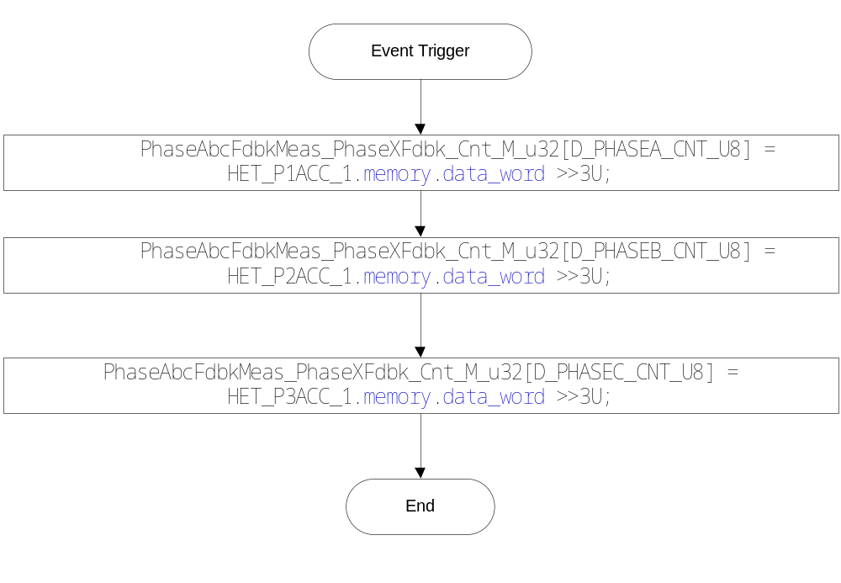

Store Local copy of outputs into Module Outputs
None

Interrupt Functions

Isr: <ModuleName>_Isr<n>
None

Design Rationale
None

(Processing of the ISR function)…..
None

Serial Communication Functions

SComm: <MODULENAME>
None

Design Rationale
None

Store Module Inputs to Local copies
None

(Processing of function)………
None

Store Local copy of outputs into Module Outputs
None

Local Function/Macro Definitions

None

GLObAL Function/Macro Definitions

Init: Cd_PHASEABCFDBKMEAS_Init1

Design Rationale
None

Module Outputs
None

Module Internal
None

Known Limitations With Design
None

UNIT TEST CONSIDERATION

None

Appendix
None

